Supplementary data

‘Multivalent binding of galactosylated cyclodextrin vesicles to lectin’

by Antonino Mazzaglia, Damien Forde, Domenico Garozzo, Paola Malvagna, Bart Jan Ravoo and Raphael Darcy.

General Remarks:
Anhydrous DMF was taken under N₂ from sealed bottles. TLC was carried out on Merck Silicagel 60 analytical plates with the specified solvent system. Cyclodextrin derivatives were detected by UV light or by dipping in 5% sulphuric acid in ethanol and heating. NMR spectroscopy was carried out on 300 MHz and 500 MHz Varian Unity Spectrometers in [D₆]-DMSO solutions at 30 ºC. The interpretation of ¹H and ¹³C NMR spectra was aided by recording COSY and ¹H-¹³C HSQC spectra. MALDI-MS was carried out at the ICTP-CNR Catania, Italy. The MALDI-MS spectrum was acquired using a Perseptive BioSystems Voyager-DE STR (Framingham, MA, USA) equipped with delayed extraction technology operating in linear mode. Positive ions formed by a pulsed nitrogen laser (λ = 337 nm) with a 3 ns pulse duration, were accelerated through 25 KV. The dried analytes 5 and 7 (1 mg) and equimolar mixture of lectin and analytes (1 mg) were respectively dissolved in H₂O (2 mL). 2,5-Dihydroxybenzoic acid (30 mg mL⁻¹ in H2O:CH3CN 9:1, v/v containing 0.1% trifluoroacetic acid ) or sinapinic acid (Sigma) at concentration of 10 mg mL⁻¹ H2O:CH3CN 1:1, v/v were used as the matrix. The sample-matrix solution was deposited (1 μL) onto the probe tip and dried at room temperature with a final amount of analyte of about 100 pmole.
Microanalysis was carried out at the Analytical Services Unit, University College Dublin.

Heptakis {2,6-dideoxy-[2-ω-bromo-oligo(ethylene glycol)-6-deoxy-6-hexadecylthio]}-β-cyclodextrin (4):
Dried cyclodextrin 2 (0.5 g, 0.14 mmol) was dissolved in anhydrous DMF (5 mL) under N₂.
Dried, recrystallised PPh₃ (0.58 g, 2.22 mmol) and NBS (0.4 g, 2.22 mmol) were added and stirred at 65 °C for 4 hours. TLC analysis (CH₃Cl: MeOH:H₂O; 50:10:1) was used to monitor progress of reaction. Upon completion (R_{f} starter = 0.55, R_{f} product = 0.90), the reaction mixture was allowed to cool , precipitated in H₂0, and the resulting yellow solid was isolated by filtration. Purification of the crude product of the phosphine compounds was achieved by stirring it in boiling MeOH. The product remained as an oily brown residue when the boiling solvent was decanted off, this process was repeated until the MeOH remained clear (of both colour and PPh₃ and PPh₃O, which were detected under a UV lamp). The product solidified on cooling and was isolated in 75% yield. NB: Cyclodextrin 4 was air-dried at ambient temperature and should not be dried in vacuum since it then becomes insoluble in all organic solvents.
Analytical data for CD 4
¹H-NMR (CDCl₃, 300 MHz) δ=5.05 (br, 7H, H-1); 4.0-3.4 (m, ca 56 H, H-3, H-5, OCH₂); 3.55 (m, 14 H, CH₂Br); 3.40 (m, 14 H, H-2, H-4); 2.95 (m, 14 H, H-6); 2.60 (m, 14 H, SCH₂); 1.57 (m, 14 H, CH₂); 1.30 (br s, 182 H, [(CH₂)_{n}]); 0.89 (t, 21H, CH₃) ppm. ¹³C-NMR (CDCl₃, 300 MHz) δ=101.0 (C-1); 81.2 (C-2, C-4); 72.5-71 (C-3, C-5, OCH₂); 33.8 (C-6); 33.8 (CH₂S); 31.6 (CH₂); 29.8 (CH₂Br); 29.8 [(CH₂)_{n}]); 29.7 (CH₂); 29.5 (CH₂); 29.4 (CH₂); 29.2 (CH₂); 22.7 (CH₂); 14.1 (CH₃). Microanalysis calculated for C₁₈₂H₃₄₃O₃₅S₇Br₇: C 56.42 %, H 8.86 %, S 5.79 %, Br 14.47%, Found: C 56.28 %, H 8.85 %, S 5.88%, Br 14.03%.

Heptakis{2,6-dideoxy-2-[S-β-1-D-galactopyranosyl −ω-thio-oligo(ethylene oxide)]-6-hexylthio}-β-cyclodextrin (5) was prepared as follows: a solution of 3 (0.23 g, 0.079 mmol) in anhydrous DMF (3 mL) was added drop wise (about 1 h) to a solution of 1-thio -β-D-galactose sodium salt (GalSNa) (Aldrich cat 1999; 0.69 g, 3.16 mmol) in anhydrous DMF (4 ml) at 80 °C. The reaction mixture was stirred for 7 days under N₂ until TLC analysis (PrOH-EtOAc-NH4OH-H2O 7:7:5:4) indicated complete conversion of compound 3 (Rf = 0.55) into 5 (Rf = 0.8). The crude product was dissolved in the minimum quantity of water and purified by size-exclusion chromatography on Sephadex G50 (column 160 x 20 mm) with water as eluent. The pure product 5 was obtained in 40 % yield.

Analytical data for CD 5:
MALDI-MS ( main peaks only) Found: m/z= 3543 [M_{11EO}-Na⁺], 3587 [M_{12EO}-Na⁺], 3678 [M_{13EO}-Na⁺], 3722 [M_{14EO}-Na⁺], 3766 [M_{15EO}-Na⁺], 3810 [M_{16EO}-Na⁺].

¹H-NMR (DMSO, 500 MHz) δ= 5.16-4.86 (br, 7H, H-1), 4.44 (br, OH), 4.28 (d, 7H, H-1,Gal) 3.76-3.48 (m, ca. 91 H, H-4, Gal; H-3; H-5; H-6, Gal; OCH₂), 3.46-3.29 (m, 35H, H-4; H-2; H-5, Gal; H-3, Gal; H-2, Gal), 3.25-2.73 (m, 28H, H-6; CH₂SGal), 2.60 (m, 14H, SCH₂), 1.6-1.25 (m, 56H, CH₂), 0.89 (t, 21H, CH₃) ppm. ¹³C NMR (DMSO) δ= 103-100 (C-1), 89 (C-1, Gal), 84-81.8 (C-4; C-2; C-5, Gal), 77.8 (C3, Gal), 76.4-72.6 (C-3; C-5; C-2, Gal; OCH₂), 71.8 (C-4, Gal), 64.5 (C-6, Gal), 37.1 (C-6), 35.2 (SCH₂R), 33.8 (CH₂), 31.4 (CH₂SGal), 32.4 (CH₂), 31.7 (CH₂), 26.6 (CH₂), 17.8 (CH₃). Microanalysis calculated for C₁₅₄H₂₈₀O₇₀S₁₄: C 50.00%, H 7.58%, S 12.12%. Found: C 50.28 %, H 7.85%, S 11.88%.

Heptakis{2,6-dideoxy-2-[S-β-1-D-galactopyranosyl −ω-thio-oligo(ethylene oxide)]-6-hexadecylthio}-β-cyclodextrin (6)
To a solution of compound 4 (0.3 g, 0.08 mmol) in anhydrous DMF (10 mL), was added drop wise (about 1 h) a solution of 1-thio -β-D-galactose sodium salt (GalSNa) (Aldrich cat 1999; 0.52 g, 2.32 mmol) under an atmosphere of nitrogen at room temperature. The reaction was left to proceed at 80°C for 1 week. TLC analysis (CH₃Cl: MeOH:H₂O; 50:10:1) was used to monitor progress of reaction. On completion, the solvent was concentrated down and the crude product taken up in the minimum amount of H₂O (5 mL). The product was then purified via size-exclusion chromatography through a column Sephadex G 50 (column 160 x 20 mm) using H₂O as eluent. Product (yield 0.2 g, 55%) was isolated as a cream solid after freeze-drying for 12 hrs.
¹H-NMR (DMSO, 500 MHz) δ= 5.2-4.9 (br, 28H, OH, Gal), 5.2-4.9 (br, 7H, H-1), 4.44(br, OH), 4.28 (d, 7H, H-1,Gal), 3.76-3.48 (m, ca. 91H, H-4, Gal; H-3; H-5; H-6, Gal; OCH₂), 3.46-3.29 (m, 35H, H-4; H-2; H-5, Gal; H-3, Gal; H-2, Gal), 3.25-2.73 (m, 28H, H-6; CH₂SGal), 2.60 (m, 14H, SCH₂), 1.5 (m, 14 H, CH₂), 1.30 (br s, 182H, [(CH₂)_{n}]), 0.89 (t, 21H, CH₃) ppm. ¹³C NMR (DMSO) δ= 103-100 (C-1), 89 (C-1, Gal), 84-81.8 (C-4; C-2; C-5, Gal), 77.8 (C3, Gal), 76.4-72.6 (C-3, C-5; C-2, Gal; OCH₂), 71.8 (C-4, Gal), 64.5 (C-6, Gal), 37.1 (C-6), 35.2 (SCH₂R), 33.8 (CH₂), 31.4 (CH₂SGal), 29.8-29.4 [(CH₂)_{n}]); 29.1 (CH₂); 23.1 (CH₂); 15.3 (CH₃). Microanalysis calculated for C₂₂₄H₄₂₀O₇₀S₁₄: C 57.49 %, H 8.98 %, S 9.58 %. Found: C 57.28 %, H 8.85 %, S 9.88 %.

Heptakis{2,6-dideoxy-2-[S-β-1-D-glucopyranosyl −ω-thio-oligo(ethylene oxide)]-6-hexylthio}-β-cyclodextrin (7) was prepared as reported for CD 5 . To a solution of CD 3 (200 mg, 0.069 mmol) in anhydrous DMF (3 mL) was added drop wise (about 1 h) a solution of 1-thio -β-D-glucose sodium salt (GlcSNa) (600 mg, 2.75 mmol). The pure product 7 was obtained in 46 % yield.
Analytical data for CD 7:
MALDI-MS (main peaks only) Found: m/z = 3916 [M_{19EO}-H⁺], 3960 [M_{20EO}-H⁺], 4004 [M_{21EO}-H⁺], 4048[M_{22EO}-H⁺].
¹H NMR (DMSO, 500 MHz) δ= 5.16-4.85 ( br, 28, OH, Glc), 5.16-4.85 (br, 7H, H1), 4.44(br, OH), 4.27 (d, 7H, H1,Glc), 3.73-3.28 (m, ca. 112H, H3; H5; H6, Glc; OCH₂), 3.20-3.12 (m, 28H, H2; H4; H3, Glc; H5, Glc), 3.1-2.98 (br s, 14H, H2, Glc; H4, Glc), 2.71-2.89 (m, 28H, H6; CH₂SGlc), 2.60 (m, 14H, SCH₂), 1.53-1.48 (m, 14H, CH₂), 1.30 (br s, 42H, CH₂), 0.89 (t, 21H, CH₃). ¹³C NMR (DMSO) δ= 103-100 (C1), 89 (C1, Glc), 85-81.5 (C4; C2; C5, Glc; C3, Glc), 77.5-73(C3; C5; C4, Glc; C2, Glc; CH₂O), 64.5 (C6, Glc), 38.1 (C6), 37.1 (C-6), 35.2 (SCH₂R), 33.8 (CH₂), 32.8 (CH₂), 31.7 (CH₂), 31.4 (CH₂SGlc), 26.6 (CH₂), 16.8 (CH₃). Microanalysis calculated for C₁₆₈H₃₀₈O₇₇S₁₄: C 50.35 %, H 7.69 %, S 11.18 %. Found: C 49.83 %, H 7.20 %, S 10.81%.

Tensiometry:
The surface tension of aqueous solutions of CD 7 was measured at room temperature with a Kruss Tensiometer K6. Doubly distilled water was used to prepare cyclodextrin solutions. The determination of CMC values covered about 20 surface tension determinations in the concentration range of 0.4 × CMC to 40 × CMC. The reported surface tension is the mean value of at least three measurements for each cyclodextrin concentration and the CMC values were calculated from a plot of the surface tension vs the negative logarithm of the cyclodextrin concentration.

Maldi mass spectrum of galactosylated CD 5
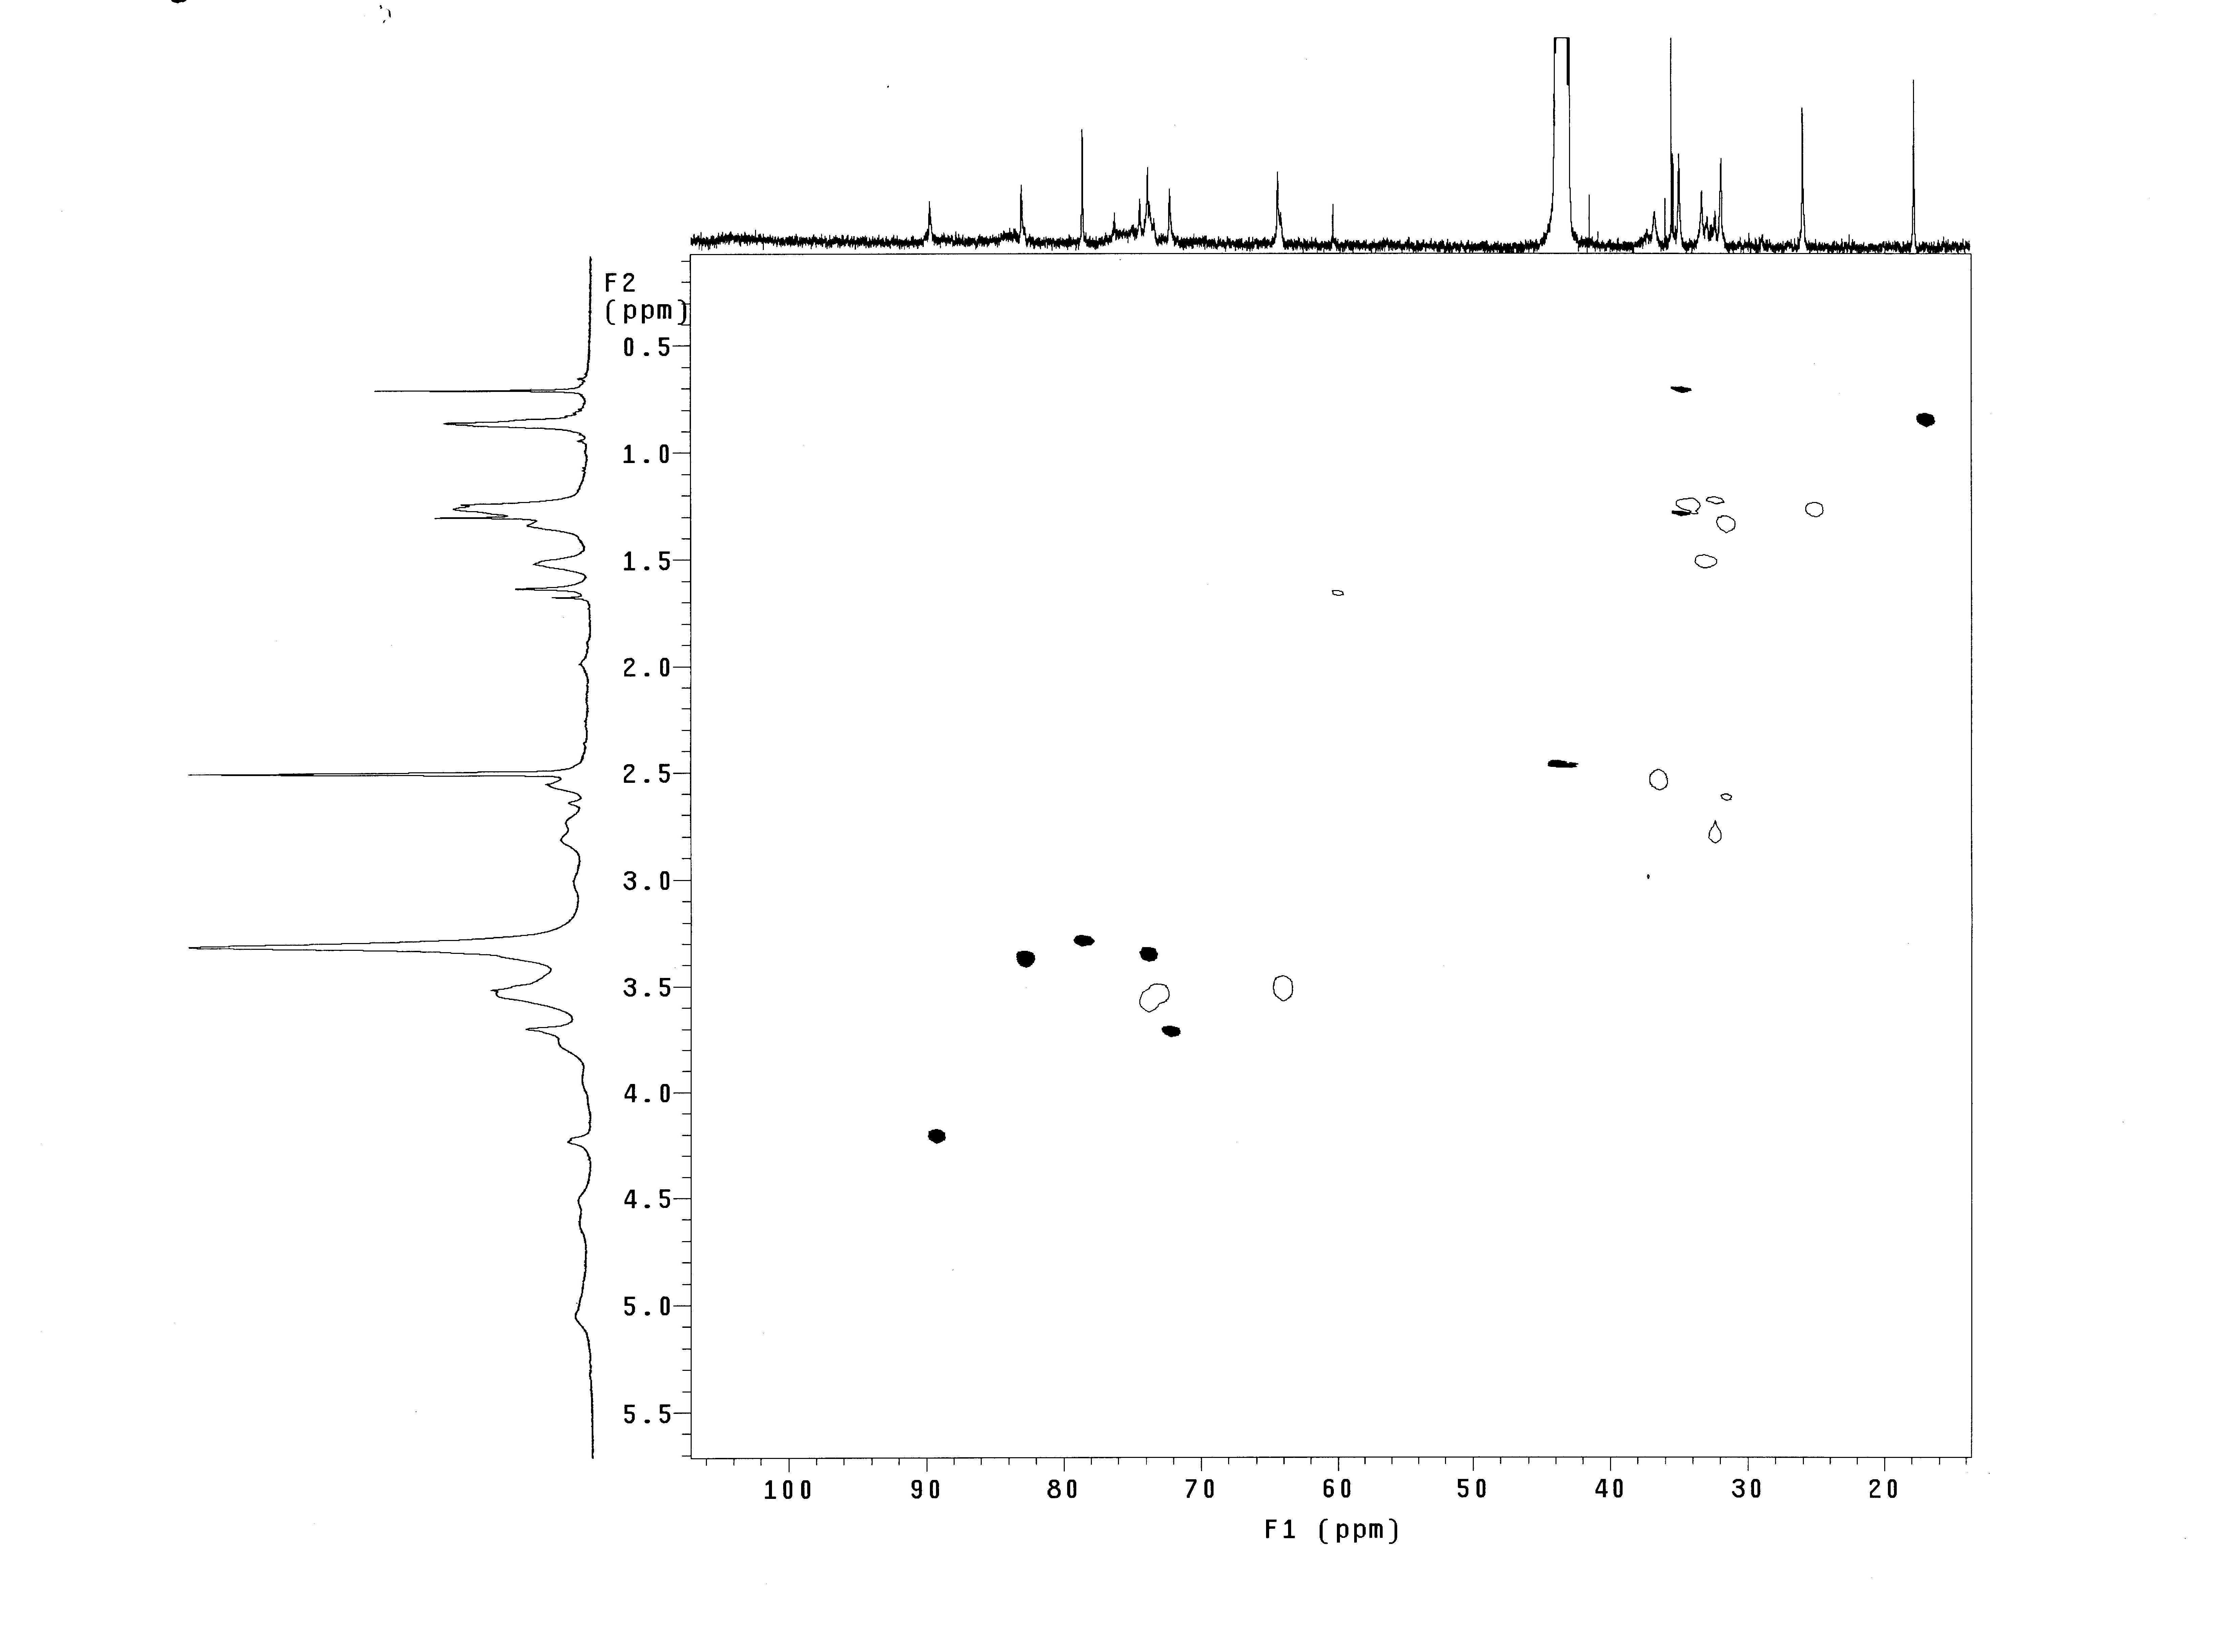
3543
3722
HSQC NMR spectrum of galactosylated CD 5
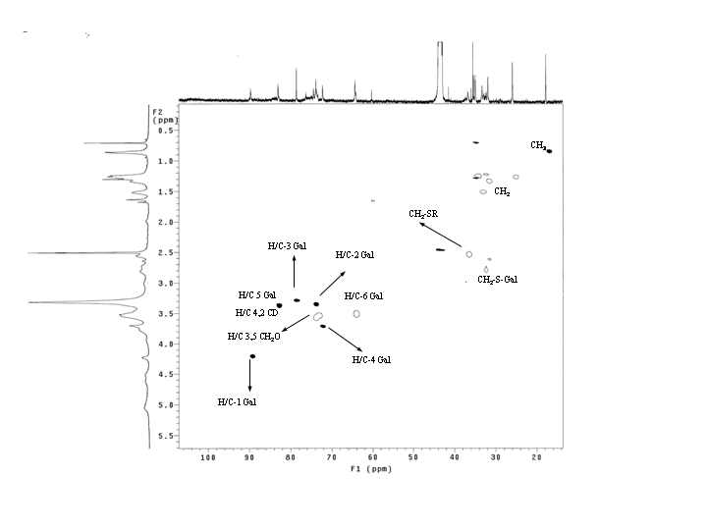

DLS of CD 5 (Contin size distributions): a, fresh; b, after 2 days; c, after 1 week.

DLS of CD 5 ( Contin size distributions): a. fresh; b, after 2 days; c, after 1 week.
e
a

c
b

CMC of glucosylated CD 7 (8.1 μM)

Maldi mass spectrum of a equimolar mixture of Pseudomonas Aeruginosa (PA-I) and galactosylated CD 5.
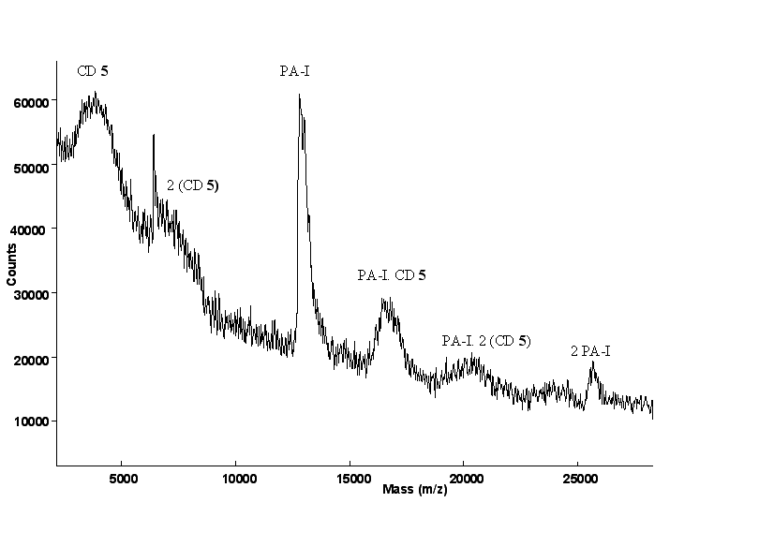

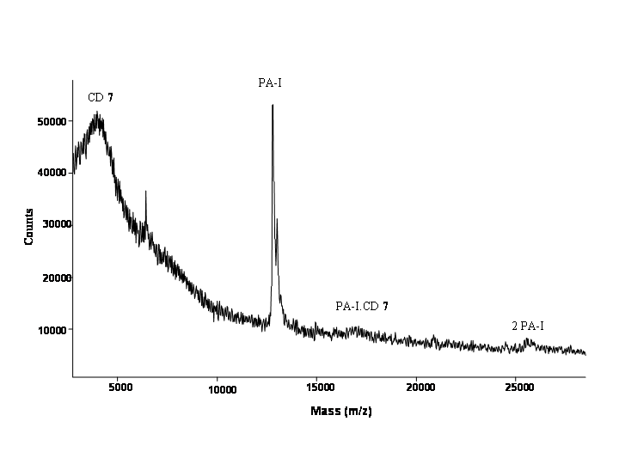
Maldi mass spectrum of a equimolar mixture of Pseudomonas Aeruginosa (PA-I) and glucosylated CD 7.

SPR investigations:
The operating conditions of the optical biosensor Iasys are reported in literature.¹⁴ From the immobilisation profile of Arachis hypogaea (AH) (data not shown), the net change in response due to the immobilisation of the lectin onto the surface, corresponds to a value of 1000 response arc seconds. This was converted into the actual amount of lectin immobilised with the use of calibration values, as follows. For planar amino surfaces, 600 arc seconds = 1 ng / mm² of protein. Area of single cuvette surface = 48 mm². These values imply that 1000 response arc seconds is equivalent to 1.67 ng mm⁻². This corresponds to a total of 80.16 ng of lectin immobilised onto the amino cuvette.
The binding experiments illustrate the obtained change in response on association of the CD analyte to the lectin (addition of analyte), and on dissociation of the CD analyte from the lectin ( regenerating lectin with buffer wash).
Statistical analysis were carried out on each of the association curves (each analyte concentration). The desired rate and affinity constant are derived by plotting k_{on} versus analyte (A) concentration where k_{on} = k_{diss} + k_{ass}[A] is the measured on-rate constant at the particular analyte (or ligate) concentration; the association rate constant (k_{ass}) and the dissociation rate constant (k_{diss}) can be calculated from the relation R_{t} = R₀ + ΔR (1-e^{Kont}) where R_{t} at any time is the measured response (arc sec) which is directly proportional to the amount bound on the surface (complex CD-AH), ΔR is the total change in response R_{max}-R₀ where R_{max} is a measure of the maximum number of binding sites available.

SPR results of binding at different concentrations of CD 5

Binding constant evaluation for AH/5
Intercept = 0.0072552 ±0.00015 = k_{diss}, Gradient = 12.269 ±0.0907 = k_{ass}
Corr Coeff = 0.991, K_{D} = k_{diss} / k_{ass} = 5.8 x 10⁻⁴ M

SPR results of binding at different concentrations of CD 6

Binding constant evaluation for AH/6
Intercept = 0.0523106 ±0.0015 = k_{diss}, Gradient = 1527.76 ±10.04 = k_{ass}
Corr Coeff = 0.9880, K_{D} = k_{diss} / k_{ass} = 3.3 x 10⁻⁵ M

